# Unit 1: Paraphrasing and Summarizing

## Task 1

1. set out > planned, started, begun, commenced ** ระวัง v.3  
   reduce > decrease, lower, minimize  
   huge > large, enormous  
   amount > number, volume
2. worried > concerned, anxious  
   threaten > affect, impact, harm  
   purity > cleanliness, pureness, quality, sterility  
   supplies > sources
3. trapped > condensed, stuck, locked   
   shale > rock, underground  
   contaminate > stain, pollute infect = for sickness  
   wells > ponds, boreholes
4. address > manage, deal with, mention, tackle, take into account  
   needed > required, demanded, essential, crucial for + N  
   deal with > handle, manage, cope with, tackle, address  
   challenging > critical, problematic, ambitious, difficult, tough, complicated
5. treating > nursing, curing, healing, medicating  
   predicted > forecast, foreseen,   
   crisis > impact, calamity, emergency, catastrophe, issue   
   scarcity > shortage, lack, insufficiency

## Task 2

1. The exact size of the state-of-the-art facility has not been finalized by the companies, but approval is being sought.
2. The plan to set up the first refinery in the state of Sarawak has been announced by a Malaysian palm oil company.
3. RM2.5bn has been raised, **of** which **RM830m** has already been spent. *(830m of 2.5bn)*
4. The Department of Energy and Climate Change will lead the review of the long-term health of the country’s refining and fuel import sectors.
5. Currently, the domestic refineries meet around 61% of the UK’s demand for refined oil products, **with** the imports **meeting** the rest. *with + V.ing*

## Task 3

1. whose oral delivery is done in three stages  
   with a 3-staged oral delivery
2. concern **about how** fracking may **be impacting** groundwater  
    (ways in which)  
   *about + N  
   have an impact on >> impact(V) + N(obj)*
3. ... these cyanides are incredibly harmful to both workers …  
   ... these cyanides can incredibly harm both workers ...
4. The improvement of the lives of more than a billion citizens could be made / could happen
5. The liquid evaporation sets up  
   The evaporation of liquid sets up

## Task 4

1. Although the capacity ... disclosed, the gov ...
   1. *effect because cause*  
      A steam-assisted drainage makes the oil sand industry extremely energy- and water-intensive **because** high-pressure steam is pumped down into the sand to free up the oil and make it possible to pump it to the surface
   2. *effect as a result of cause(Noun)*  
      A steam-assisted drainage makes the oil sand industry extremely energy- and water-intensive **as a result of** high-pressure steam which is pumped down into/being pumped ....... making the oil
2. and : replace "and" to "In addition"  
   Not only but also : *Not only V S but also S V*  
   The researchers estimated that **not only** could safe drinking water be provided ... **but** production of the cartridges ... would **also** create ...
3. but : replace "but" to "However,"  
   despite :  
   **Despite** poor management of even plentiful resources which can initiate a wave of ... and conflict, Australia can assist …  
   Despite the fact that poor management …

## Task 5

The Arctic National Wildlife Refugee (ANWR), which covers more than 77000 sq.km. of widely uninhabited region, is the biggest wildlife refuge in the U.S.

The region has been protected by law since 1980. However, a 6100 sq.km. stretch of land along the coast – known as the 1002 Area – was portioned out for exploration of oil and gas.

A study by the U.S. Geological Survey showed estimated technically recoverable reserves from 4.3 to 11.8bn bbl of oil.

* *since 1980 can change the tense of sentence due to the subject*
* *Beware of connector and capitalize – don't mistype*
* *Try more to change active - passive*

Key solution

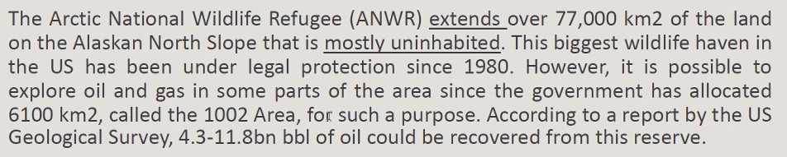

## 

## Task 6

Summary in 80-100 words

[Task 6 Summary - Group 7](https://docs.google.com/document/d/1e5h0zN-YXBxuoaKCGtPo-8nBypzahAFGXKCeOKt8LAA/edit#)

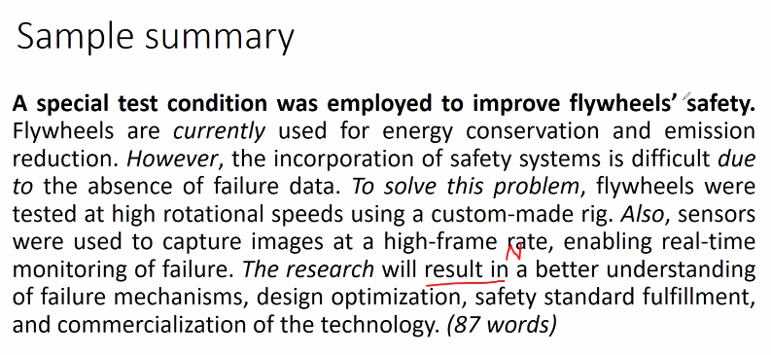

## Task 7

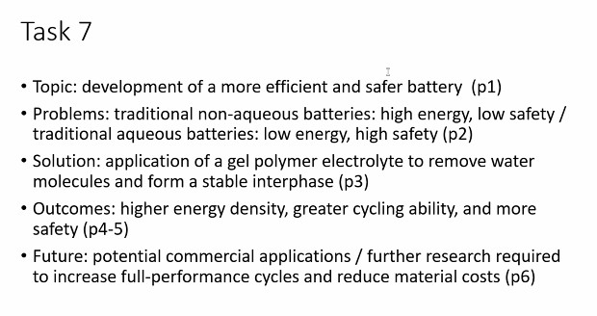

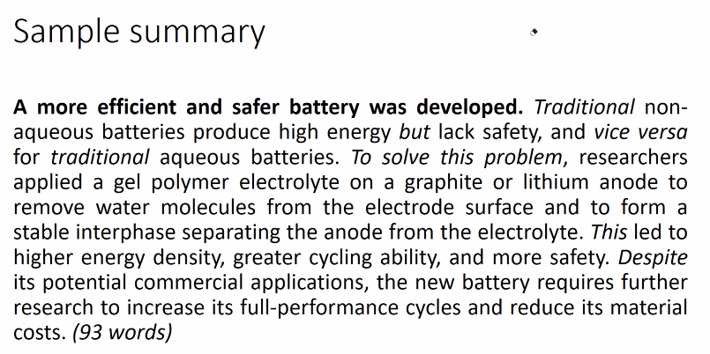

## Task 8

## Task 9

The scientists research security weaknesses and cyberattacks.

Smart grid technology leads to both monitoring enhancement and chance of hacking.

Due to the interconnectedness of the grid, where hackers target the control mechanism, can also cause enormous effects leading to blackouts, equipment failure and islanding.

Consequently, the research has been organized to detect the performance and weaknesses of automated systems, using quantitative methods to increase power grids security and reliability.

Furthermore, more ways to enhance the cybernet quality are improving specific regulations about infrastructure and adding cybersecurity insurance. (87 words)

# Unit 2: Definition

Grammar

* Prescriptive – by latin people
* Descriptive

## Task 1

1. Logistics is the process which involves transferring goods through manufacture, storage and transportation.
2. A chief operations officer is the person who is in charge of operations.
3. Copper is a substance which is easily shaped, and allows heat and electricity to pass through.  
   Copper is a substance easily shaped, allowing heat and electricity to pass through.
4. General Motors is a company where automobiles are manufactured.
5. A generator is a machine which produces electricity.
6. An engineer is a person who designs machines, buildings or public works.
7. Gravity is the force which attracts bodies toward the center of the earth

*Beware of tense*

## Task 2

1. An adhesive is a material which bonds the surfaces of two other materials.
2. Brazing is a metal joining technique which uses a molten filler metal alloy having a melting temperature greater than about 425 °C.
3. Drawing is a deformation technique which is used to fabricate metal wire and tubing.
4. An elastomer is a polymeric material which may experience large and reversible elastic deformation
5. Concrete is a composite material which consists of aggregate particles bound together in a solid body by cement

## Task 3

1. An alumino-thermic weld is a butt welding process by which (whereby) two rails are joined permanently.
2. A clevis is a U-shaped piece with holes through which a pin or bolt is run.
3. A face is the exposed area of a coal bed from which coal is extracted.
4. A roughing stand is the first rolling stand through which metal passes during hot rolling.
5. A magnetic pole is the area, at which magnetic field leaves or enters the part, on a magnetized part.
6. A robbed out area is the part of a mine from which the pillars have been removed.
7. A bridge strike is an incident in which a road vehicle or its load (or a vessel in navigable waters) collides with.
8. The autoignition temperature of a substance is the lowest temperature at which the substance will ignite in a normal atmosphere without an external source of ignition such as a flame or a spark.
9. An electrolytic tin plate is light-gauge, low-carbon, cold reduced steel on which tin has been deposited.
10. An interlaced track is a track into which a second track is incorporated to permit two-way working within a restricted width without the need to install switches.

## Task 4

1. with
2. in
3. by
4. by
5. in
6. through (pass through) , X (pass+obj)
7. X
8. X
9. through (pass through) , X (pass+obj)
10. by
11. at
12. X
13. X
14. by
15. through
16. at
17. on
18. from
19. from (extracted from)
20. through (pass through) , X (pass+obj)

*at = speed, temperature, rate*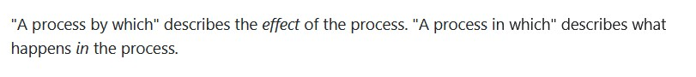

*system in which,*

*by = method, process, amount*

*S which V, N which(obj) S V*

*of which always equals to whose*

## Task 5

*cancer = general , A cancer = A (type of) cancer*

*Don't count material*

*Vegetable = (gernal) NC, (the variety of vegetables) C*

| 1. NC  2. C  3. NC  4. C  5. NC | 6. NC (baggage too)  7. C  8. NC  9. NC  10. NC | 11. NC  12. C  13. NC  14. NC  15. NC | 16. NC  17. C  18. NC  19. NC  20. C |
| --- | --- | --- | --- |

## Task 6

| 1. a, an, X  2. a, a, an, an  3. an, X, an, a, a  4. a, a (one), a (seven)  5. X, an, an, a, a | 6. an, a, a, an  7. a, an, X, an (honest), X  8. X, an, X, a, a, X, a, an (MP3), a  9. a, an, a  10. a, a, X, an, an |
| --- | --- |

*Beware of sound (vowel)*

*50* ***B****aht, 50 pound****s,*** *50 euro****s,*** *50 dollar****s***

## Task 7

*The + adj = plural noun*

*The something of (a) something [ The door of a car, The roof of a house, The ministry of education ]*

A

| 1. a  2. a  3. the  4. the  5. a | 6. the  7. x  8. a  9. a  10. the | 11. the  12. the  13. a  14. the (น้ำที่เติมไปข้อ7)  15. x | 16. The steam  17. the  18. the  19. the  20. the |
| --- | --- | --- | --- |

B

| 1. a  2. x  3. x  4. x  5. the | 6. x  7. a  8. x  9. x  10. a | 11. the  12. a  13. the  14. the  15. x | 16. the  17. a  18. x  19. the  20. the |
| --- | --- | --- | --- |

## 

## Task 8

1. **(x)** Magnetic flux density is **the** magnetic field which is produced in **a** substance by **an** external magnetic field.
2. **A** refractory is **a** metal or **(a)** ceramic which may be exposed to extremely high temperatures without deteriorating rapidly or melting.
3. **(x)** Galvanized steel is **(x)** steel of which **the** surface is coated with **a** layer of zinc (in order) to prevent corrosion.
4. **A** barney is **a** small truck which is attached to **a** rope or **(a)** cable to push cars up **a** slope or **an** inclined plane.
5. **A** panel point is **the** point in **a** framed structure where*(at which)* **a** vertical or **(a)** diagonal member and **a** chord intersect. *(intersect at a panel point)*
6. **A** fixture is **a** device which is used to hold **a** workpiece while manufacturing operations are performed on **the** workpiece.
7. **(x)** Surface irrigation is **a** broad class of irrigation methods by which water is distributed over **the** soil surface by gravity flow.
8. Column flotation is **a** precombustion coal cleaning technology **in** which **(x)** coal particles **attach** to **(x)** air bubbles that rise in **a** vertical column. *จับได้เอง*
9. Ampacity is **the** amount of current through which **a** conductor can carry without exceeding its specified temperature in amperes. *(carry through)*
10. Oxidation pond is **a** shallow lagoon in which wastewater is purified by sedimentation as well as **(x)** aerobic and anaerobic treatment.
11. Conventional gas is **a** natural gas which occurs in **a** normal and **(a)** permeable reservoir rock in **a** gaseous or crude oil form. *(a … form)*
12. **A** pick path is **a/the** route in **a** picking area which a picker follows to complete its picking tasks. *(a picker follows a pick path)*
13. **The** ignition temperature is **the** minimum temperature to which **a (type or x)** fuel in **the** air must be heated to start self-sustained combustion. *(to which เพราะต้องไล่อุณหภูมิจากต่ำไปสูง)*
14. **A** field-effect transistor is **a** transistor in which **the** voltage on one terminal creates a field that allows or disallows conduction between **the** other two terminals.   
    *Field = เกิดข้างใน = ใช้ in*
15. Random location storage is **a** storage method by which **a** product is stored in any location.
16. **A** meridian is a surveyed longitudinal reference line **from** which ranges are surveyed to the east and the west.
17. **A** gore is **a** thin triangular plot of land whose*(of which)* **the** boundaries are defined by surveying **(x/the)** adjacent properties. *(boundaries of land)*
18. **A** rack-supported building is **a** warehouse design which includes **(x)** structural pallet racks to support **the** roof of **a** building instead of posts.
19. **An** expansion joint is **a** non-insulated fishplated rail joint which is designed to accommodate **the** longitudinal thermal expansion of **(x)** rails. *(the N of N)*
20. **A** skid is **a** portable platform which enables **a** forklift, **a** pallet jack, or **(x)** other material handling equipment to lift, move, and store various loads.

*สำหรับ Subject: A metal and ceramic = singular, A metal and a ceramic = plural*

## Task 9

1. **A** retainer plate is **a** plate **on** which removable parts such as **a** cavity or **an** ejector pin **are mounted***(ขยาย parts)* during **the** process of molding.
2. **An** absorption tower is **a** vertical tube in which rising gas is partially absorbed by liquid in the form of falling droplets.
3. **An** infrared photoconductor is **a** conductor of which **the** conductivity increases when it is exposed to **(x)** infrared radiation. *(form of radiation = countable)  
   (increase = is increased [by meaning, decrease too])  
   (of which THE dont forget the)*
4. **(x)** Mechanical weathering is a process by which (x) physical forces break down or reduce **(x)** rock to **(x)** smaller fragments, involving no chemical change.
5. Line balancing is a production strategy which concerns setting **the** intended rate of production for **(the)** required materials so that they *(materials)* can be manufactured within **a** particular time frame.  
   *which concerns setting the intended rate ↔ which concerns* ***the*** *setting* ***of an*** *intended rate  
   Change concerns to is concerned with*
6. **(An)** engineering application is a situation in which engineering knowledge, skills and methods are applied to provide **a** beneficial result.  
   *Application – mostly uncountable but an application = 1 time use*
7. Fluoridization is a process by which fluoride is added to **(x)** public water supplies to reduce the risk of dental decay.
8. **A** variable indicator tube is **a** vacuum or (a) gas-filled display tube of which **the** area of luminescence is varied by adjusting **a** control voltage or amperage.  
   *In which is fine, but of which is better  
   Current (กระแสไฟฟ้า) = countable, so this context, control voltage is countable*
9. **A** lookout station is **a** structure on **a/the** shore on which **(x)** personnel *( = staff)* watch over **(x)** events at sea or along **the** shore.  
   *We should change “on which” to “where” for better sound (not on and on)*
10. **A** galvanometer is **an** instrument (which is) used to detect, compare, or measure **(x)** small electric currents depending on **the** magnetic effect produced by **an** electric current.

*Process = in which / by which /* ***whereby***

# Unit 3: Processes

## Task 1 Just underline the verbs

## Task 2

* Start from
* Then, in the next step, before, after, finally
* The next/final stage is V.ing

## Task 3 Beware of tense

1. Friction is reduced by the application of oil.
2. The earthquake occurred on April 18, 1906.
3. Fluorescent light has been linked to melanoma, a vicious form of skin cancer, in the last few years. *Linked to ↔ linked with*
4. X-ray was discovered by Roentgen in 1895.
5. The light that you see here shows that the laser beam is being reflected from the moon back to the earth at this moment.
6. Physicists have recently found traces of the subatomic particle known as ‘W’.
7. The ejection of volcanic dust into the atmosphere will slightly lower / will have slightly lowered global temperatures for the next few years.
8. A microscope is usually composed of an objective, a specimen stage, and a light source.   
   *ประกอบไปด้วย = consist(s) of / comprise + obj / be composed of*
9. Electronic engineers are currently investigating the feasibility of three dimensional television.
10. Thanks to satellite photographs, the earth’s aurora is shown to be nearly round.

| Type of sentences   1. Simple sentence / one independent clause 2. Compound sentence / two independent clauses 3. Complex sentence / one independent clause + one dependent clause (or we call the dependent = adverbial clause)   ใช้ adverbial ไม่สัมพันธ์กับ main sentence = dangling modifier  E.g. Watching ร่างทรง on Netflix, the movie was so scary. << but movie cannot watch itself  ระวัง อย่าเรียงผิด read the examples in page 6-8 Having gone เกิดก่อน, เกิดหลัง |
| --- |

## Task 4

1. After being produced by other factories, the parts are delivered to the assembly plant.
2. After arriving at the plant, the parts are sorted and put into inventory (by workers).
3. After being processed in the paint shop, the car frames are passed onto the assembly line.
4. Before assembling the seats onto the chassis, the technician checks the manifest sheet.
5. After being assembled, the seats are wrapped in plastic to prevent damage.
6. After finishing the seat assembly, the technician will inform his supervisor.
7. While waiting for the technician to finish, the supervisor inspects other parts of the assembly line.
8. After being checked by the inspector, the assembled units are moved into stock.

## Task 5

Stupid task.

## Task 6

* This paragraph describes the cement production process.
* First, after being delivered in bulk to **a** cement plant, raw materials are crushed and homogenized into a mixture which is fed into a rotary kiln (an enormous rotary pipe).
* Then, the huge kiln is heated by **a** 2000 °C flame inside of it and *(is)* quickly cooled to 100-200 °C.
* The final product of this phase, (which is) called “the clinker”, is stored in a huge silo.
* Next, gypsum and inert materials are added to the clinker.
* After that, all ingredients are ~~grinded~~ ground to make a fine, homogeneous powder (cement).
* Finally, after being stored in the silo, the cement is dispatched either in bulk or bags to the site where it will be used.
  + Finally, the cement is stored in the silo before being dispatched either in bulk or bags to a site where it will be used.

## Task 7

* This paragraph describes suspension bridge construction / how a suspension bridge is constructed.
* First, towers of multiple columns *(ตึกที่มีหลายเสา)* are erected on a/**the** tower foundation by using high-strength reinforced concrete.
* Next, large devices (saddles), which carry / carrying through the main suspension cables, are positioned on (the) top of the towers.
* After that, anchorages are constructed to resist **the** tension of cables and (to) **form** as the main anchor system for the entire structure.
* Then, temporary suspended walkways (catwalks) are erected before the main cable spinning devices are installed.
* The next step, suspender cables are engineered and cut to precise lengths before being looped over cable bands.
* After completing the primary structure, the engineers then install lighting, handrails, and paving.

## Task 8

* This paragraph describes power generation in a binary cycle geothermal power plant.
* First, geothermally heated water is drawn up from the ground through different sets of pipes to start an electricity generation process.
* ~~After being stored in the heated water, the energy is transferred to the working fluid through a heat exchanger.~~
  + Second, the energy (which is) stored in the heated water is transferred to the working fluid through a heat exchanger.
* Then, the working fluid is vaporized in the heat exchanger and used to power a turbine or an electrical generator.
* After passing from the working fluid through the turbine, the vapor is recondensed.
* Next, the vapor is piped back to the heat exchanger.
* Finally, **the** excess water vapor returns into the ground before being reheated for later use.

## Task 9

* The paragraph describes the process of preparing kaolinite.
* First, kaolinite is passed through a sieve to remove clusters and agglomerated particles.
* Then, the kaolinite is dried at the temperature of 105 °C for 24 hours inside an oven.
* After being calculated for the right amount and chosen as the contaminant content, gas oil is sprayed on the dried kaolinite of a predetermined weight.
* Next, the kaolinite and the gas oil **are** manually blended so that a homogeneous mixture is obtained.
* After that, the mixture is placed in a covered container and kept in an/the oven at the temperature of 30 °C for seven days to come to equilibrium.
* Finally, the contaminated kaolinite sample is molded before being tested.

# Exam (Q1 and Midterm) preparation

## Quiz 1_pa 2.pdf (2019 B Part2)

1. Cathode-ray tube is an electron tube in which a beam of electrons can focus in the small area varied in position and intensity on the surface. (-0.5)
2. Vulcanization is a chemical process which converts natural rubber or related polymers into more durable materials by heating them with sulfur. (/)
3. Isomerization is a process in which one molecule is transformed into another molecule with the same chemical composition but with a different structure. (/)
4. Leading load is a load which is predominately capacitive so that its current leads a voltage applied to the load. (/)
5. Synchronism is a condition with which a motor runs at the speed directly related to a frequency of power applied to the motor and is not depended on other variables. (-0.5)

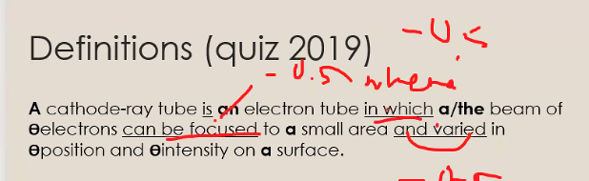

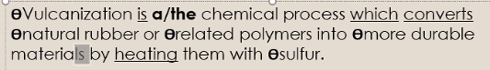

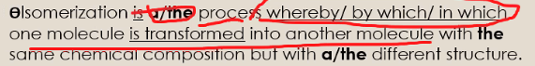

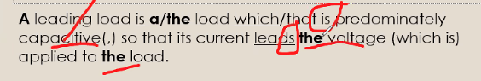

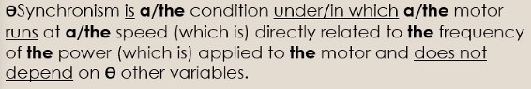

1. A cathode-ray tube is an electron tube in which a beam of electrons can be focused (-0.5) to a small area (and) varied in position and intensity on the surface.
2. Vulcanization is a chemical process which converts natural rubber or related polymers into more durable materials by heating them with sulfur.
3. Isomerization is a process in which one molecule is transformed into another molecule with the same chemical composition but with a different structure.
4. A leading load is a load which is predominately capacitive so that its current leads a voltage applied to the load.
5. Synchronism is a condition in which a motor runs at the speed directly related to the frequency of the power applied to the motor and is not depended on other variables.

## Mock exam 1

### Part2

1. A capacitive crosstalk is a phenomenon in which a signal on one line is capacitively coupled to an adjacent line.
2. A circuit simulator is a piece of software which copies the behavior of a real hardware circuit before it is built.
3. A forward converter is a power-supply switching circuit which transfers the energy from the primary state to the secondary state when the switching transistor is on.
4. A dechlorination is a process in which excess chlorine is removed from disinfected wastewater prior to discharge into the environment.  
   *prior to = before (preposition form)*
5. A/**The** bubble point is a/**the** temperature in/**at** which the first bubble of vapor is formed when liquid that consists of two or more components is heated.

### Part3

* This paragraph describes the facial tissues production.
* First, used printer paper and water are added to a giant machine which is called a pulper to produce pulp.
* Next, ~~the~~ air is injected into the pulp so that ink can be detached from the fibers in the pulp and clings to **the** air bubbles floating to the top of the pulper.
* After being refined and cleaned, the pulp is fed through several rollers.
* Then, the pulp is broken up by a screw conveyor belt, rinsed with clean water and spread evenly onto the screen conveyor belt.
* After that, the hot air dryer at the bottom of the screen conveyor belt eliminates **the** water in **the** pulp and pushes out large rolls of paper sheets.
* Before being cut into facial tissues, the paper sheets are flattened by applying moderate tension.

## Summary (2019 B Part1 80-100 words)

*The researchers study the effect of virtual embodiment, the illusion of a virtual body of another person. The team is curious about the different behavior of people who experienced a virtual body. They conducted the experiment with 30 young men. First, the participants complete three tests, showing their thoughts toward themselves and others. Fifteen participants wore a body-tracking suit and a virtual reality headset of Einstein's body, normal adult bodies in the rest. Then, they do some exercises and redo the tests. The result shows Einstein's body can increase cognitive task performance in low self-esteem people and also reduce bias of older people. However, this study should be reconducted with a larger group in the future.*

| The researchers study the effect of virtual embodiment. The team is curious about the different behavior of people who experienced a virtual body. They conducted the experiment with 30 young men. Starting with three tests, then fifteen participants wore a body-tracking suit and a virtual reality headset of Einstein's body, normal adult bodies in the rest. Then, they do some exercises and redo the tests. The result shows Einstein's body can increase cognitive task performance in low self-esteem people and also reduce bias of older people. However, this study should be reconducted with a larger group in the future. |
| --- |

"Virtual reality can create the illusion of a virtual body to substitute your own, which is called virtual embodiment," says Professor Mel Slater of the University of Barcelona. Previous research found that virtual embodiment can have striking effects on attitudes and behavior. For example, white people who experienced a virtual black body showed less unconscious stereotyping (called implicit bias) of black people.

"We wondered whether virtual embodiment could affect cognition." says Slater. "If we gave someone a recognizable body that represents supreme intelligence, such as that of Albert Einstein, would they perform better on a cognitive task than people given a normal body?"

The team recruited 30 young men to participate in a virtual embodiment experiment. Prior to the embodiment, the participants completed three tests: a cognitive task to reveal their planning and problem-solving skills, a self-esteem task to assess their views about themselves, and an age bias task to identify their opinions towards older people. The participants then put on a body-tracking suit and a virtual reality headset. Half of them experienced a virtual Einstein body and the other half a normal adult body. After completing some exercises in the virtual environment with their new body, they repeated the age bias and cognitive tests.

The researchers found that people with low self-esteem performed the cognitive task better following the virtual Einstein experience, compared with those who experienced a normal body of someone their own age. Those exposed to the Einstein body also had a reduced bias against older people.

Bias is based on considering someone to be different from yourself. Being in an older body may have subtly changed the participants' attitudes by blurring the distinction between elderly people and themselves. Similarly, being in the body of someone extremely intelligent may have caused the participants to think about themselves differently, allowing them to unlock mental resources that they don't normally access.

To further investigate the phenomenon, a larger study with more participants - and including men and women - is needed. However, the results so far suggest that the technique could be useful in education. (345 words)

## In-class Writing Assessment (COVID19 80-100 words)

The study about the effective way to kill coronavirus with ultraviolet light-emitting diodes is conducted. Nowadays, coronavirus is harmful especially in vulnerable people. Chemical spraying is a legacy way to remove coronavirus but it is time-consuming and labor-intensive. So, the researchers conducted the portable and effective UVLED method test. They used various wavelengths and found that 285 nm wavelengths can destroy more than 99.99% of coronavirus within half a minute and this bulb is cheaper than 265 nm bulb. This research leads to adaptation by installing UV light in robots, air conditioning and water systems. However, this method is not safe for direct human contact and needs more research of integrating multiple methods together.

| The study about the effective way to kill coronavirus with ultraviolet light-emitting diodes is conducted. Chemical spraying is a legacy way to remove harmful coronavirus but it is time-consuming and labor-intensive. So, the researchers conducted the portable UVLED method test. They found that 285 nm wavelengths can destroy more than 99.99% of coronavirus within half a minute and this bulb is cheaper than 265 nm. This research leads to adaptation by installing UV light in robots, air conditioning and water systems. However, this method is unsafe for direct human contact and needs more research of integrating multiple methods together. (100 words) |
| --- |

Coronavirus disease (COVID-19) is an infectious disease caused by a newly discovered coronavirus. Most people infected with the COVID-19 virus will recover without requiring special treatment, while older people and those with medical problems are more likely to develop serious illness.

Researchers from Tel Aviv University (TAU) have proven that the coronavirus can be killed efficiently, quickly, and cheaply using ultraviolet light-emitting diodes (UVLEDs).

“Effective solutions to disinfect the coronavirus are what the entire world is currently looking for," said Professor Hadas Mamane, Head of the Environmental Engineering Program at TAU's School of Mechanical Engineering. "Presently, the problem is that in order to disinfect a bus, train, sports hall, or plane by chemical spraying, you need

physical manpower, and in order for the spraying to be effective, you have to give the chemical time to act on the surface.”

However, disinfection systems based on UV-LED bulbs can be installed in the ventilation system and air conditioner, for example, and sterilize the air sucked in and then emitted into the room.

“We discovered that it is quite simple to kill the coronavirus using UV-LED bulbs that radiate ultraviolet light," she explained. "We killed the viruses using cheaper and more readily available UV-LED bulbs.”

The researchers tested the optimal wavelength for killing the coronavirus and found that a length of 285 nanometers (nm) was almost as efficient in disinfecting the virus as a wavelength of 265 nm, requiring less than half a minute to destroy more than 99.9% of the coronaviruses. This result is significant because the cost of 285 nm UV-LED bulbs is much lower than that of 265 nm bulbs, and the former are also more readily available.

Eventually, as the science develops, the industry will be able to make the necessary adjustments and install the bulbs in robotic systems or air conditioning, vacuum, and water systems, and thereby be able to efficiently disinfect large surfaces and spaces.

It is important to note that it is very dangerous to try to use this method to disinfect surfaces inside homes. To be fully effective, a system must be designed so that a person is not directly exposed to the light.

In the future, the researchers will test their unique combination of integrated damage mechanisms on direct and indirect damage to viruses on different surfaces, air, and water.

## Definition Exercise

**1. acceleration/ rate / velocity of body/ change with time/ and direction / that change act.**

* Acceleration is a rate at which the velocity of the body is changed with the time and direction that change acts.
* (Solution) Acceleration is a rate at which the velocity of a body changes with time and the direction in which that change acts.

**2. deflection/ displacement of structural member/ or system under load.**

* Deflection is a displacement of a structural member or system under load.
* (Solution) Deflection is a displacement of a structural member or system under a load.

**3. gage/ refer/ thickness of sheet of material/ or distance between centerlines/ in set of holes/ usually perpendicular to joist/ or joist girder.**

* A gage refers to the thickness of sheet of material or a distance between centerlines in a set of holes which are usually perpendicular to the joist or joist girder.
* (Solution) Gage refers to the thickness of a sheet of material or the distance between centerlines in a set of holes which is usually perpendicular to a joist or joist girder.

**4. girder/ main horizontal member/ span between two main supports/ and carry other members/ or vertical loads within structure.**

* A girder is a main horizontal member which spans between two main supports and carries other members or vertical loads within the structure.
* (Solution) A girder is **the** main horizontal member which spans between **(the)** two main supports and carries other members or vertical loads within the structure.

**5. joist/ structural load-carrying member/ with open web system/ support floors and roofs/ utilize hot-rolled or cold-formed steel/ and design as simple span member.**

* A joist is a structural load-carrying member with open web system which supports floors and roofs, utilizes hot-rolled or cold-formed steel and designs as a simple span member.
* (Solution) A joist is a structural load-carrying member with **an** open web system which supports floors and roofs by utilizing hot-rolled or cold-formed steel and (which) is designed as (a) simple span member.

# Unit 4: Abstracts and Introductions

## Task 1

A  
 Background (1)-(2)  
 Objective (3)  
 Procedures (4)-(7)  
 Results (8)-(9)  
 Conclusions (10)

B  
 Background (1)  
 Objective (2)  
 Procedures (3)-(4)  
 Results (5)  
 Conclusions (6)

## Task 4

A

1. because
2. This study aims to
3. compare
4. To achieve
5. were measured / were calculated / were determined
6. The results showed
7. Furthermore / Moreover
8. collected / gathered
9. In conclusion / Based on the results
10. to improve / to enhance / to increase

B

1. lead to / urge / necessitate / call for (and present perfect form)
2. aims to examine
3. on (effect of something on something)
4. with / using
5. were tested / were experimented / were performed / were conducted
6. showed that
7. occurred / took place
8. had
9. The difference in
10. are discussed / will be discussed

C

1. to
2. allows / enables / permits
3. by (by: focus in verb, with: focus in noun)
4. Due to
5. purpose / design / use (should be in V.2 but this paper breaks the rule)
6. observe / recorde / analyze
7. increase / improve / enhance
8. but also
9. Based on the results / From the findings / In conclusion
10. status / one

## Task 5

A

1. due to increased importance of flexibility in company development models, start-up support structures, such as business incubators / pay / more attention to flexible service offerings  
   Due to the increased importance of flexibility in company development models, start-up support structures, such as business incubators pay more attention to flexible service offerings.
2. identify / best context for incubator’s service customization strategy / and examine / effect of incubator’s industry segmentation efforts on incubatee survival and growth  
   The study aims to identify the best context for **the** incubator’s service customization strategy and (to) examine the effect of the incubator's industry segmentation efforts on incubatee survival and growth.
3. achieve research objectives, data / collect / 166 Brazilian incubators / incubators / implement / service customization strategy and industry segmentation policy / during year of 2015-2016  
   To achieve the research objectives, data were collected from 166 Brazilian incubators who **had implemented** the service customization strategy and **the** industry segmentation policy during the year of 2015-2016. (data = plural, beware of tense (before than before))
4. findings show that service customization / significant factor / through this factor / incubator’s industry focus / can influence / survival and growth of incubatee   
   The findings showed that service customization was a significant factor through which the incubator’s industry focus could influence the survival and growth of incubatee. (ใช้ V.2 เพราะยังไม่เป็นทฤษฎี ถ้าเป็นทฤษฎีจะใช้ V.1, mentioned in 1.)
5. Furthermore, it / find / that incubator’s industry focus / not automatically result in / higher performance level / since / there / be / no statistically significant relationship between incubator’s industry segmentation and incubatee survival and growth  
   Furthermore, it was found that the incubator's industry focus did not automatically result in the higher performance level since there was no statistically significant relationship between the incubator’s industry segmentation and the incubatee survival and growth.

B

1. in electrical and electronic equipment industry, increase in production to meet market needs / lead to / generation of large quantities of waste, including waste printed circuit boards  
   In the electrical and electronic equipment industry, **an** increase in production to meet **(the)** market needs leads to the generation of large quantities of waste, including waste printed circuit boards.
2. conduct technical and environmental assessment of gold extraction from solid residue / solid residue be obtain during recovery of base metals from waste printed circuit boards  
   The study aims to conduct **a** technical and environmental assessment of gold extraction from solid residue which is obtained during **the** recovery of base metals from the waste printed circuit boards.
3. achieve research objective, technical performance of extraction process / evaluate / in terms of current and dissolution efficiency and specific energy consumption during process of gold electrowinning  
   To achieve the research objective, **the** technical performance of the extraction process was evaluated in terms of current and dissolution efficiency and specific energy consumption during the process of gold electrowinning.
4. as for environmental impact of extraction process, assessment / perform / determine recovery of 1 kg of gold in identified optimal operating conditions  
   As for the environmental impact of the extraction process, the assessment was performed to determine **the** recovery of 1 kg of gold in **(the)** identified optimal operating conditions.
5. it / find that / developed gold recovery process / be not only efficient / but also involve low environmental impact  
   It was found that the developed gold recovery process was not only efficient, but also involved **a** low environmental impact.

C

1. in price-based home energy management (HEM) methods, controller / determine / energy consumption of controllable appliances in household / respond to electricity price parameters and customer preferences  
   In price-based home energy management (HEM) methods, a controller determines the energy consumption of controllable appliances in a household to respond to electricity price parameters and customer preferences.
2. prioritize operations of controllable appliances from perspectives of customers / by apply price-based HEM method  
   The study aims to prioritize **the** operations of controllable appliances from the perspectives of customers by applying the price-based HEM method.
3. achieve research objective, values of lost load (VOLL) of different appliances / define / indicate their operational priority  
   To achieve the research objective, **the** values of lost load (VOLL) of different appliances were defined to indicate their operational priority.
4. considering appliances’ VOLL and operational constraints as well as electricity fees, optimization problem / propose / minimize energy and reliability costs  
   Considering appliances’ VOLL and operational constraints as well as electricity fees, an optimization problem was proposed to minimize energy and reliability costs.
5. results / show that / proposed method / effective / in optimize scheduling of household electrical requirements of smart homes / in terms of time-varying electricity costs  
   The results showed that the proposed method was effective in optimizing **the** scheduling of household electrical requirements of smart homes in terms of time-varying electricity costs.

## Task 6-10 (do in the book)

## 

## Task 11

A

1. while priority alarm messages for machine-type communication (MTC) in industry applications / require / guaranteed delays of only a few dozen milliseconds / super-critical applications / call for / below-10-ms access  
   While priority alarm messages for machine-type communication (MTC) in industry applications are required for guaranteed delays of only a few dozen milliseconds, super-critical applications are called for below-10-ms access.
2. propose methods for improve 3GPP MTC access procedure / achieve significant performance boost for alarm messages  
   The study aims to propose methods for improving **a/the** 3GPP MTC access procedure to achieve **a** significant performance boost for alarm messages.
3. first method propose / encompass / SMS-like approach / whereby / alarm / transmit / in secure and backward-compatible form over connection-establishing access channel  
   The first method proposed encompassed an SMS-like approach whereby **an** alarm transmitted in **a** secure and backward-compatible form over **a** connection-establishing access channel.
4. second method / use / secure and previously agreed sequence of random access codes / convey super-critical alerts within a few milliseconds  
   The second method used **a/the** secure and previously agreed sequence of random access codes to convey super-critical alerts within a few milliseconds.
5. it / find that / two methods / not only achieve / control-compliant access delays / but be also / highly energy-efficient  
   It was found that **the** two methods not only achieved control-compliant access delays, but were also highly energy-efficient.

# Exam (Q2 and Final) preparation

## Abstract supplement 2

*file:///D:/Term6/TechWritEng/final/5500308%20Abstract%20Writing%20Supplement%202%202021%20_2.pdf*

* Jumpamine chloride (JCl-) is an interesting natural waste product in many species of frogs, which leads to many studies of the advantages of this product reabsorption.
* The objectives of this project are to determine the effects of Jumpamine chloride on jumping performance in frogs of the genus Rana, which can be seen in jump distance, and to study about the temperature factor affected on jumping distance.
* To achieve the objectives, the drug was injected into the bloodstream and the average jumping distance was measured under the controlled water temperature. Additionally, the same procedure was done with various temperatures. Both functions were done on two species of frogs, Rana pipiens and Rana iwanna, to identify the species-specific factor.
* As a result, in 25°C water, JCl- was highly effective on only Rana pipiens for the jumping distance test and there was no significant difference between the control group and treated group of Rana iwanna. However, in Rana iwanna, the jump distance graph exponentially increased in 30-90°C, which could imply the reason for dissimilarity seen in the jumping distance test.
* In conclusion, JCl- injection has an effect on jumping distance in both species with different temperature ranges.
* (196 words)

## Result supplement 2

*file:///D:/Term6/TechWritEng/final/5500308%20Results%20Writing%20Supplement%202%202021%20_2.pdf*

* Figure 1 shows the relationship between age, task repetitions, and performance in two learning tasks.
* In both tasks, the score rapidly increased at a lower number of task repetitions and slightly increased when over 40 times repetitions in task 1 and 30 times in task 2. This can imply that the more repetitions has less effect on the scores.
* From the results, the younger group had the better performance scores compared to the older in every number of task repetitions, implying brain deterioration could appear in older age.
* The results also indicated that the trend of performance score is not changing much in different ages, showing that the performance score of two tasks were in the same form of graph in every age group.
* Based on the findings, it can be implied that age, task repetitions, and performance scores have strong relationships.